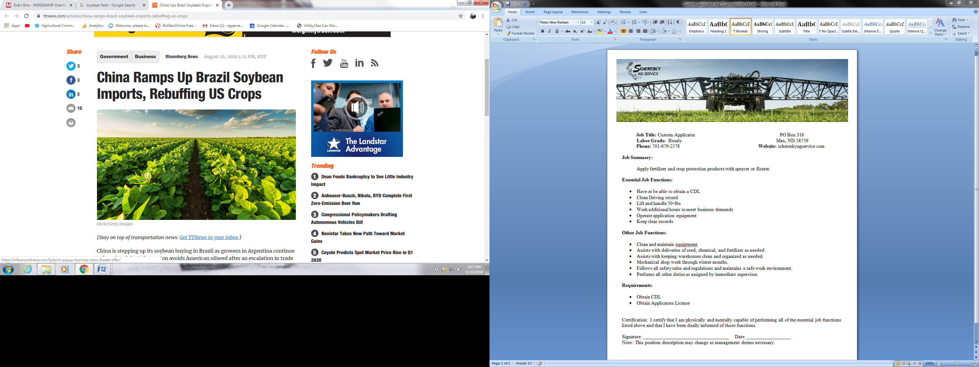

**Job Title:** Crop Scout Intern PO Box 316

**Labor Grade:** Hourly Max, ND 58759  
**Phone** 701-679-2578 **Website:** schereskyagservice.com

**Scheresky Ag Service**

**Max, ND**

**Job Summary:**

Spring/Summer Crop Scout Intern will inspect producers’ fields and record weeds, insects, diseases and any other observations. These observations are communicated through the scouting app to the crop consulting manager for recommendations, and then to the producer. Crop Scout Interns play an important role in the services offered to help producers make timely, informed, and economical decisions.

**Essential Job Functions:**

* Scout assigned fields on a daily basis.
* Identify and stage crops.
* Create an accurate report of field condition and findings.
* Identify weeds, insects, and diseases and document in the report.
* Communicate with Field Agronomist and Crop Consulting Manager.

**Other Job Functions:**

* Clean and maintain vehicle and all-terrain vehicle (ATV).
* Follow all safety rules and regulations to maintain a safe work environment.
* Perform all other duties as assigned by immediate supervisor.

**Essential Job Requirements:**

* Positive customer service attitude.
* Ability to work outdoors for extended periods of time under all-weather environments.
* Learn to identify over 100 regional broadleaf and grass species, insects, and diseases.
* Willing to learn new scouting techniques.
* Ability to operate scouting program on an iPad.
* Ability to operate an ATV.
* Communicate effectively with supervisor and co-workers.
* Perform job functions in an organized and timely manner.
* Work overtime as needed.
* Keep all Scheresky Ag Service and Scheresky Farm information confidential.
* Work well with others in a team environment.

If interested or have any questions please call or email: Kristine (701) 898-7237 or agservekristine@restel.com